# 

How we run the code

1. We must download the anaconda from this link

<https://www.anaconda.com/>

1. Download the VScode from this link and install it

<https://code.visualstudio.com/download>

1. Go to the extension part in VScode and download the python and Jupiter extensions

|  |  |  |
| --- | --- | --- |
|  |  |  |

1. Insert the file of code and file of dataset in same folder and open it by VScode

1. To train the model open the melanoma22.ipynb and click in run all button.



1. To run the gui open folder deploy and chose file gui.py

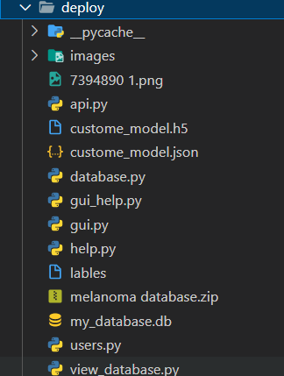

1. The chose run button in vscode



1. Few seconds and the main screen popped up

